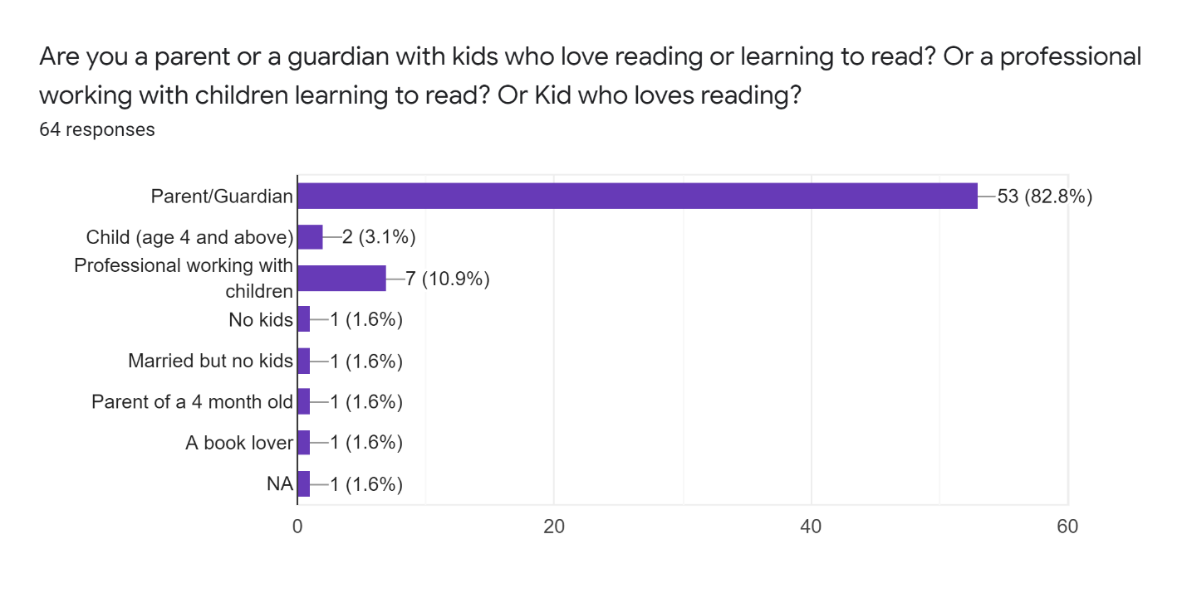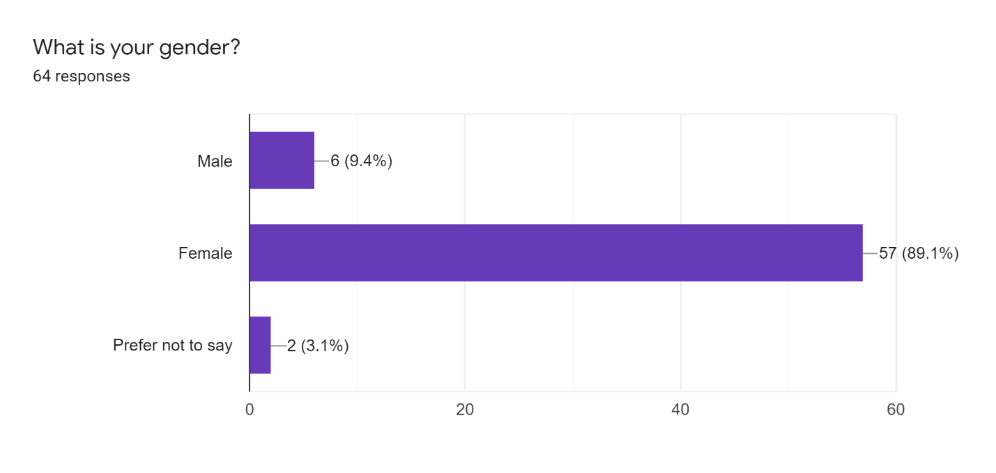

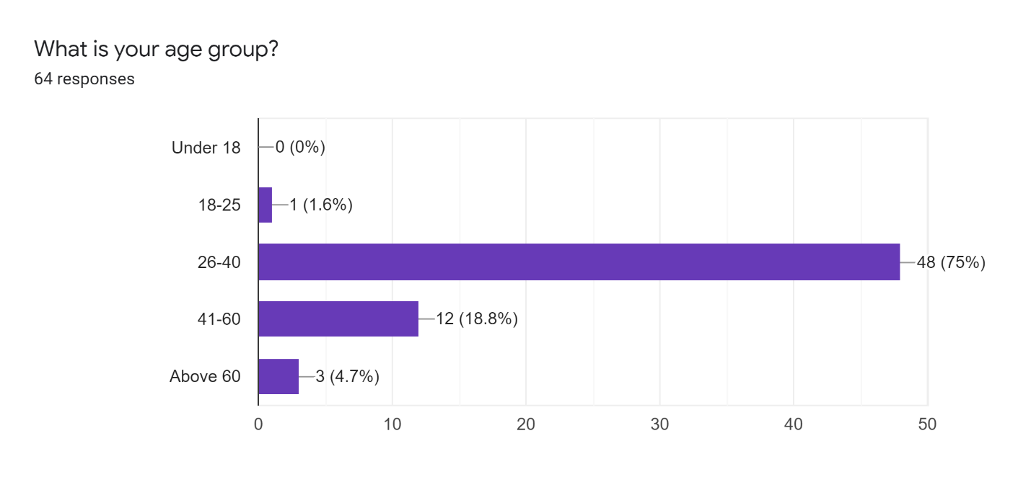

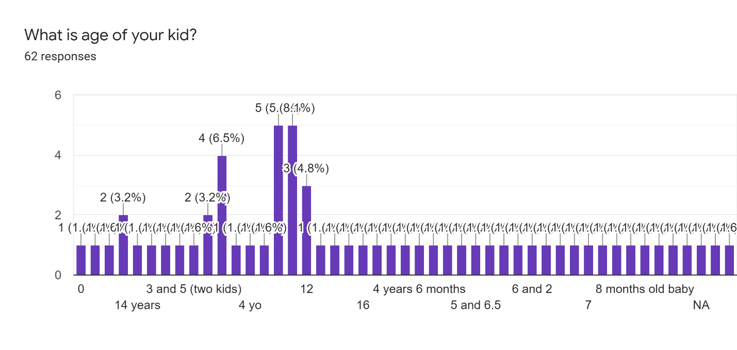

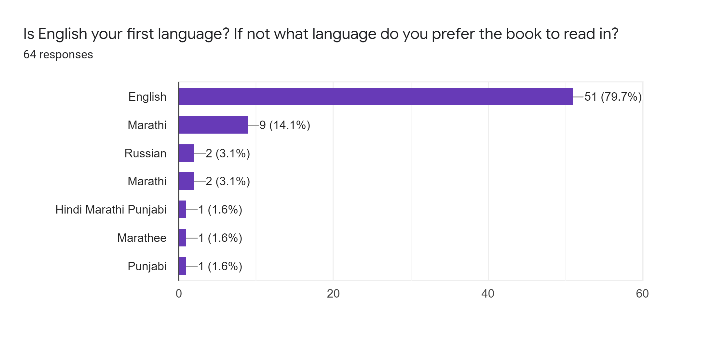

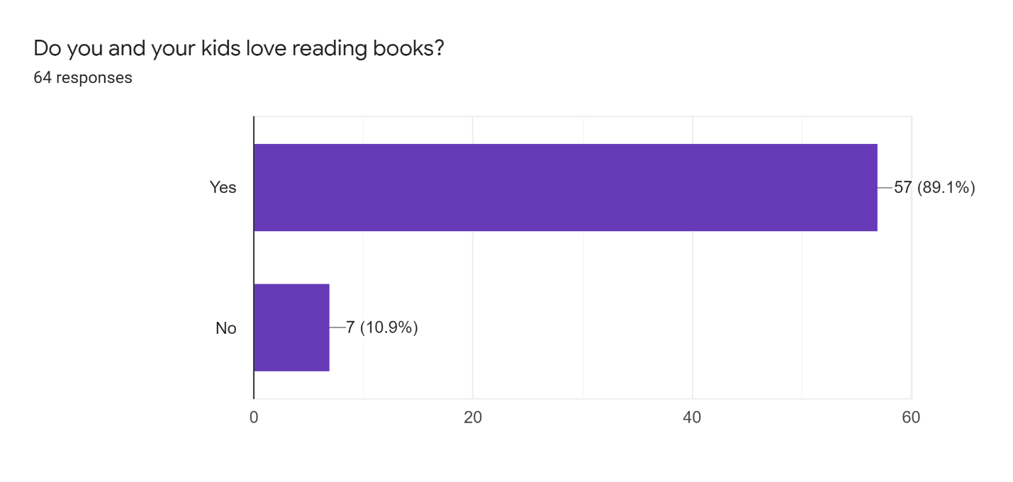

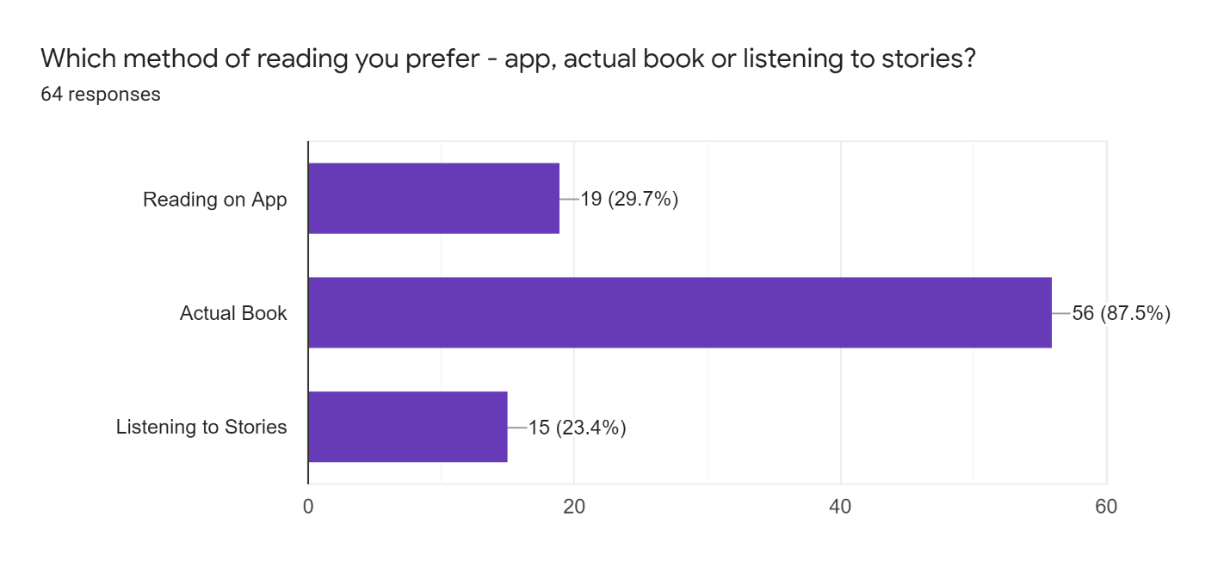

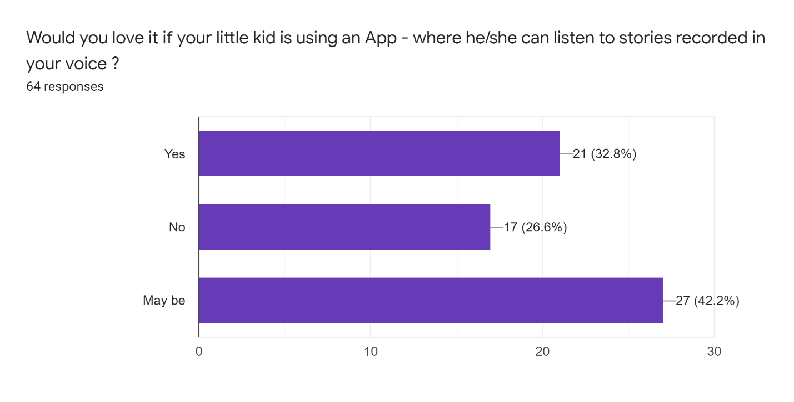

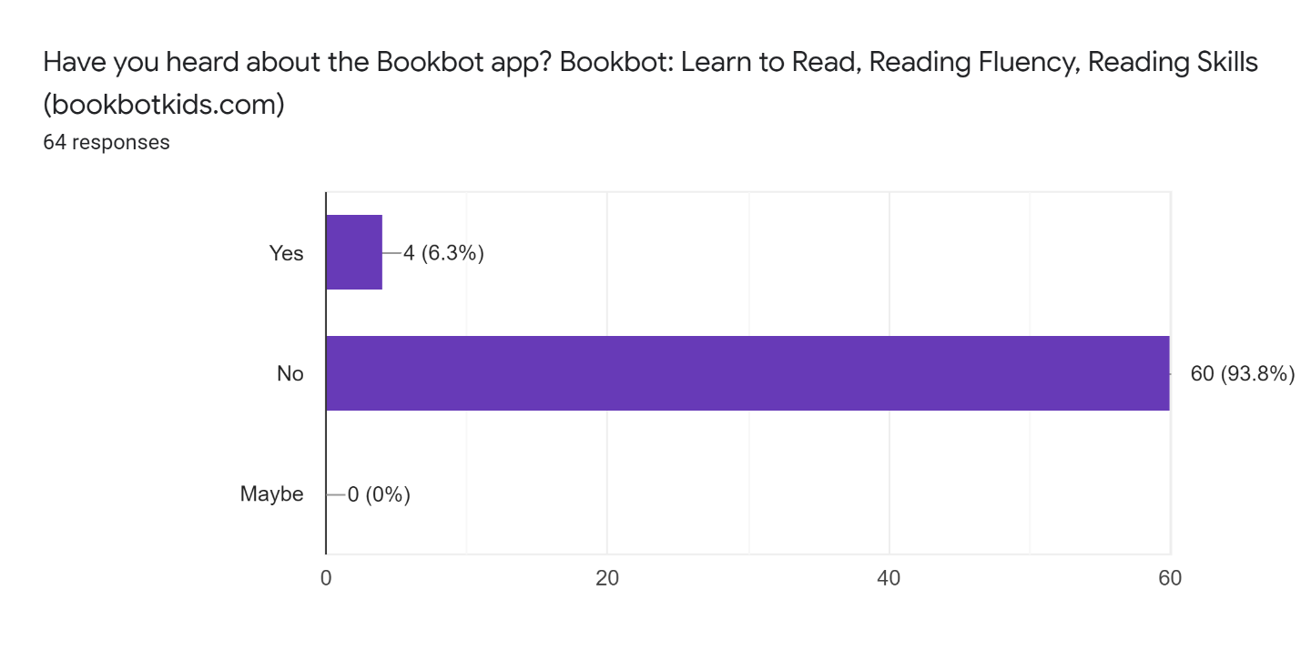



**What features would you like in an app for reading or encouraging kids to read books.32 responses**

* Pictures
* They have read to me options for all the books and built in dictionary

I think there should be a reward for children reading and showing their understanding. More variety of books and stories would definitely encourage them

Something where they can write or choose storyline’s as well

interesting books, variety

Interaction

Rewording system More funny stories

may be glossary like actual books so that kids know about new difficult words

A clear ,easy way of story telling, no pop up add on the side, related suggested stories based on yhe research.

None I prefer kids read actual books

Interactive options depending on child's development and age e.g. child is able to point to screen or provide a verbal response

Simple language

simplicity to use

-

Lots of colorful images, amazing creative characters, big font

No grammatical mistakes and hard words speller and synonyms for the word

In addition to sound the text also to be shown. I find children can speak well but spellings are not good specially words with same pronunciations.

Face reading book with expressions

I prefer real books. But if had to be app like a kindle so they can see the words being read.

Ease of searching for books and affordable prices

None

pictures

NA

Feel of the book

would not prefer my child to read a book on app.

* kid friendly and very interactive

Big picture with story telling

Would love to have voice recording facility

Easy to use for kids

If you love reading on any app, what is the name of the app? What you like about the app and what you don’t?

34 Responses

Epic books

I like YPRL library app for the selection of books. I think more variety should be there

N/A

iBooks as it connects to the App Store but that is for older books I haven’t tried kids books yet

Audible can use it when running chores

wushka

Screen time is detrimental to kids before 2yrs old those are the current guidelines

Storybots

Abc kids, - kid loosing ineterest quickly, smal pictures and letters + independently can read

wushka. I like as there is a quiz at the end which helps to understand about inerlretation abilities

I dont prefer app yet,iblike to actual read fory kid .My kid also likes to losten stories available on youtube or library website.

Kobo

No.apss till now

Myon

Not readen from any app

-

Epic

storyboxlibrary.com.au

Its digital loses personal touch like feelings expressions only voice can't have the same effect like one reading the book

IReader, wattpad, kindle. In some of the apps we have to wait for the authors to publish the whole book.

Reading easy

Audible. I like how I can speed up the reader to get thru books faster and it plays thru my car

Kindle - i like the menu options and the ease of purchasing another book when needed

None

Story tell app

Bookmark, Original book font and Pictures

Kindle

I read actual books

ANY

none

Reading eggs

I have not used any app

I don’t like reading on app